**Spring SOA Test Assignments**

1. **Create a field on Account named "Number of Contacts". Populate this field with the number of contacts related to an account.**

**Ans:-**

trigger countContactsTrigger on Contact (after insert, after update, after delete, after undelete) {

Set<Id> setAcctId = new Set<Id>();

if(Trigger.IsInsert||Trigger.IsUpdate||Trigger.IsUndelete) {

for (Contact con : Trigger.New) {

setAcctId.add(con.AccountId);

}

}

if(Trigger.IsDelete) {

for(Contact con : Trigger.Old) {

setAcctId.add(con.AccountId);

}

}

List<Account> accList = [Select Id, Number_of_Contacts__c,(Select Id from Contacts)from Account where Id in:setAcctId];

for(Account acc : accList ){

acc.Number_of_Contacts__c = acc.Contacts.size();

}

update accList;

}

**Output :**

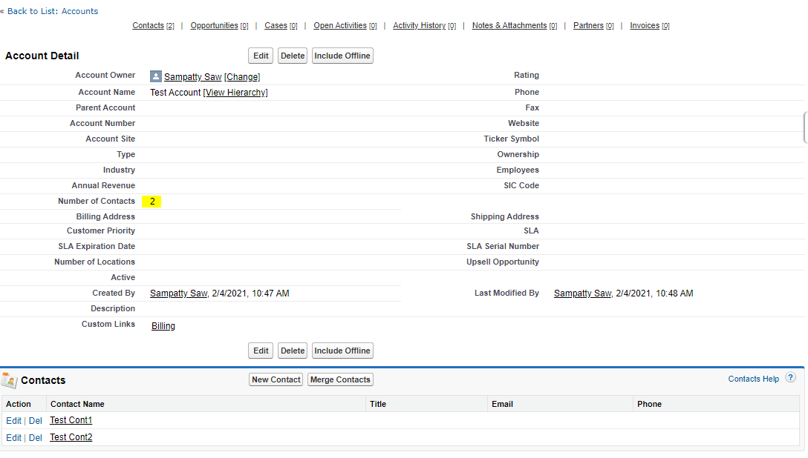

1. **Build a basic lightning component that can query a list of 10 most recently created accounts and display it using a lightning app.**

**Ans:-**

**Apex Class : (AccountAuraDisplay)**

public class AccountAuraDisplay {

@AuraEnabled

public static List<Account> getAccountRecord()

{

return new List<Account>([Select id, Name, Phone, Type from Account where Type != null LIMIT 10 OFFSET 0]);

}

}

**Lightning Components: (ListofAccounts)**

<aura:component controller="AccountAuraDisplay" implements="force:appHostable,forceCommunity:availableForAllPageTypes,

flexipage:availableForAllPageTypes" access="global">

<aura:handler name="init" value="{!this}" action="{!c.doInit}" /> <!-- calling doInit method in Component Controller -->

<aura:attribute name="accLst" type="Account[]"/> <!-- create Array type Account variable-->

<article class="slds-card">

<div class="slds-card__header slds-grid">

<header class="slds-media slds-media_center slds-has-flexi-truncate">

<div class="slds-media__figure">

<span class="slds-icon_container slds-icon-standard-account" title="description of icon when needed">

<lightning:icon iconName="standard:account" size="large" alternativeText="List account"/>

</span>

</div>

<div class="slds-media__body">

<h2>

<a href="javascript:void(0);" class="slds-card__header-link slds-truncate" title="Account">

<span class="slds-text-heading_small">Account</span>

</a>

</h2>

</div>

</header>

</div>

<div class="slds-card__body">

<table class="slds-table slds-table_bordered slds-no-row-hover slds-table_cell-buffer">

<thead>

<tr class="slds-text-title_caps">

<th scope="col">

<div class="slds-truncate" title="Name">Name</div>

</th>

<th scope="col">

<div class="slds-truncate" title="Type">Type</div>

</th>

<th scope="col">

<div class="slds-truncate" title="Phone">Phone</div>

</th>

</tr>

</thead>

<tbody>

<aura:iteration items="{!v.accLst}" var="acc"> <!-- iteration account record.-->

<tr class="slds-hint-parent">

<th scope="row">

<div class="slds-truncate" title="Adam Choi"><a href="javascript:void(0);">{!acc.Name}</a></div>

</th>

<td>

<div class="slds-truncate" title="Company One">{!acc.Type}</div>

</td>

<td>

<div class="slds-truncate" title="{!acc.Phone}">{!acc.Phone}</div>

</td>

</tr>

</aura:iteration>

</tbody>

</table>

</div>

<footer class="slds-card__footer"><a href="javascript:void(0);"><!--View All <span class="slds-assistive-text">entity type</span>--></a></footer>

</article>

</aura:component>

**Controller.js : (ListofAccountsController.js)**

({

doInit : function(component, event, helper) {

helper.getAccontRecord(component); // Calling Helper method

}

})

**Helper.js :** **(ListofAccountsHelper.js)**

({

getAccontRecord : function( component ) {

var action = component.get("c.getAccountRecord"); //Calling Apex class controller 'getAccountRecord' method

action.setCallback(this, function(response) {

var state = response.getState(); //Checking response status

var result = JSON.stringify(response.getReturnValue());

if (component.isValid() && state === "SUCCESS")

component.set("v.accLst", response.getReturnValue()); // Adding values in Aura attribute variable.

});

$A.enqueueAction(action);

}

})

**Application: (DisplayAccounts.app)**

<aura:application extends="force:slds" >

<c:ListofAccounts />

</aura:application>

Output :

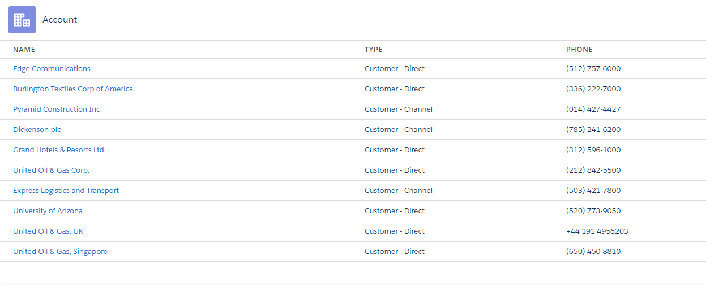

1. **Make a basic http callout and print the result using system.debug**

**Ans:-**

**SFDCStopCallout.apxc :**

public with sharing class SFDCStopCallout {

public static void getBlogs() {

HTTP http = new HTTP();

HTTPRequest request = new HTTPRequest();

request.setEndpoint('https://sfdcstop.herokuapp.com/blogs');

request.setMethod('GET');

HTTPResponse response = http.send(request);

if(response.getStatusCode() == 200) {

SFDCStopBlogsWrapper responseWrapper = SFDCStopBlogsWrapper.parse(response.getBody());

System.debug('Author:- ' + responseWrapper.author);

if((responseWrapper.blogs!=null) && (!responseWrapper.blogs.isEmpty())) {

for(Integer i=0; i<responseWrapper.blogs.size(); i++) {

SFDCStopBlogsWrapper.Blogs blog = responseWrapper.blogs.get(i);

System.debug('Blog Id:- ' + blog.id);

System.debug('Blog Title:- ' + blog.title);

System.debug('Blog URL:- ' + blog.url);

}

}

}

}

}

**SFDCStopBlogsWrapper :**

public class SFDCStopBlogsWrapper {

public class Blogs {

public String id;

public String title;

public String url;

}

public String author;

public List<Blogs> blogs;

public static SFDCStopBlogsWrapper parse(String json) {

return (SFDCStopBlogsWrapper) System.JSON.deserialize(json, SFDCStopBlogsWrapper.class);

}

}

------------------------------------------------------------------------------------------------------ Thank you!